|  |
| --- |
| **Experimentation (part 1)** |
| Follow the following steps and tasks. In some of them, you will be asked to take screenshots, save your time or download files. |
| The collaborative configuration during this experiment consists of a group that configures the product and a product manager who checks the configuration and runs the conflict resolution process.  *If you are reading this, you are a member of the group that will configure the product ☺* |

* **Task 1 (Registering)**

**Current time (put the time when you are ready to start this task):** HH: MM

1. Click on « Register »

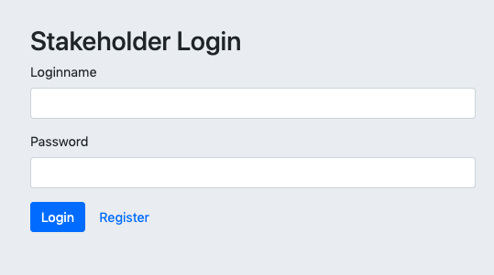

1. Enter your personal information and the desired substitution rules

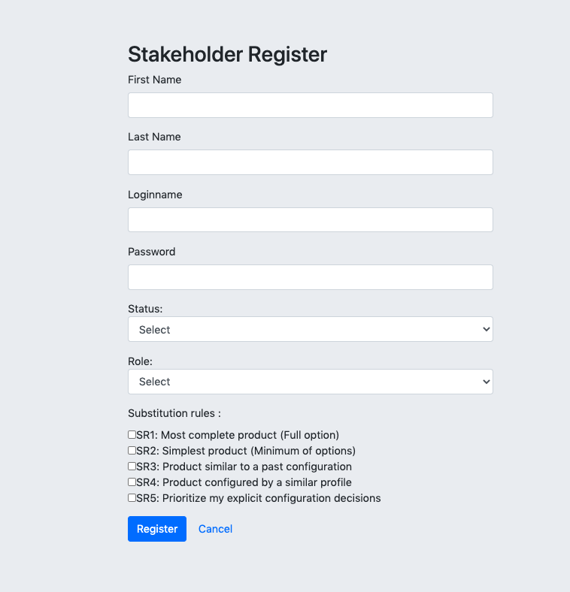

1. Click on « Register »

**Final time (record your current time after finishing this task):** HH: MM

**Task 2 (Configuring a product)**

**Current time (put the time when you are ready to start this task):** HH: MM

1. Login with the login and password you chose in the 2nd step of task 1. 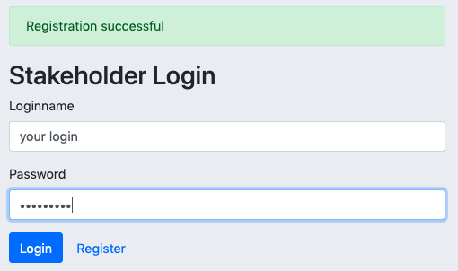

Once logged in, take a screenshot of the window that appears and put it here:

|  |
| --- |
|  |

1. Import the XML file of the features model to be configured via the following link :[github.com/sabrinacri/Colla-Config-tool/Web_portal_model.xml](https://github.com/sabrinacri/Colla-Config-tool/blob/main/Web%20portal_Domain-Webportal_model.xml)

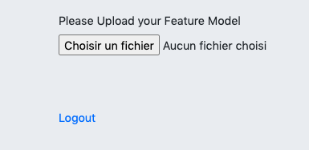

1. Select the list of desired characteristics by checking the box for each desired characteristic as shown in the Figure below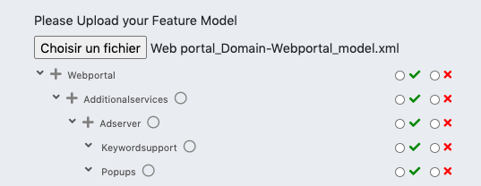
2. Select the list of undesired characteristics by checking the box for each undesired characteristic as shown in the Figure below

Take a screenshot(s) of all your configuration choices and put it here:

|  |
| --- |
|  |

1. Click on « Save and close »

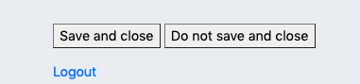

1. Click on « Logout »
2. To see the synthesis of your choices and the corresponding constraint propagation, Login with the login and password "admin, admin" then click on "Merge". The product manager will proceed similarly through this interface to manage conflicts.
3. Click on « Logout »

**Final time (record your current time after finishing this task):** HH: MM

* **Task 3 (Get the result of conflict resolution).**

The management of conflicts and their resolution are dealt with in the space reserved for the Product Manager (Management Interface below).

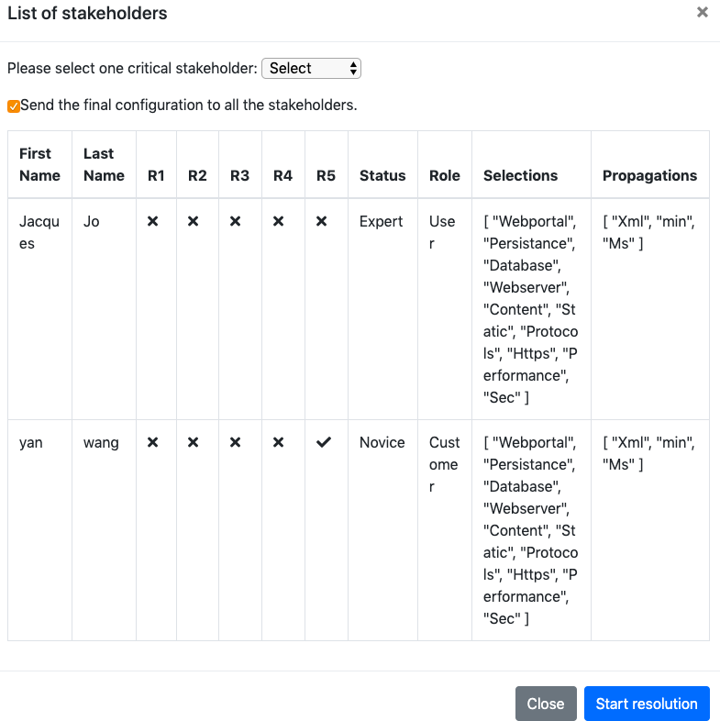

**Current time (put the time when you are ready to start this task):** HH:MM

1. To see the final configuration after having resolved the conflicts, login with the login and password you chose in the 2nd step of task 1.
2. Import the XML file of the features model that you have configured.
3. Log out.

**Final time (record your current time after finishing this task):** HH: MM